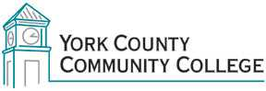

College Council
Tuesday: December 2nd, 2014
12:30 – 2:00 in the Middle Cafeteria

AGENDA

1. Call to Order

2. Approval of Agenda

3. Approval of December 2014 College Council Minutes

4. Updates
4.1 President’s Update (I)
4.2 Standing Committee reports (C)
4.3 Steering Committee reports (C)
4.4 Master Planning Ad-Hoc committee (C)
4.5 Building Ad-Hoc committee (C)

5. Old Business
5.1 Ad-Hoc Committees (D)

6. New Business
6.1 Welcome Kathleen Rinaldi-Boisvert (I)

7. Announcements

8. Public Comment

9. Adjournment

Note: In keeping the College Council’s Agenda Item Request Form, agenda items are coded as follows: A= Action Item; C= Committee Report; D= Discussion; I= Information

