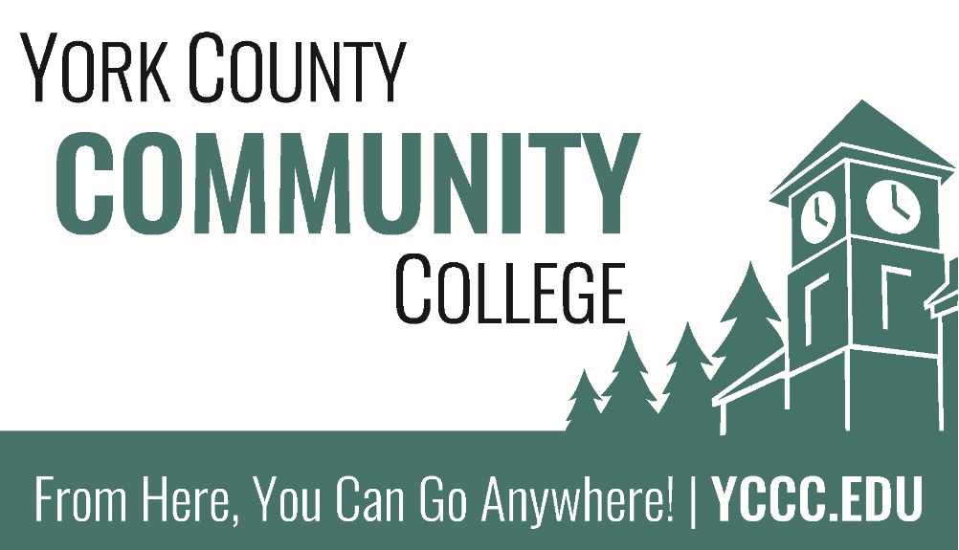

York County Community College
Strategic Plan
2018-2023

Table of Contents
Message from the President 3

Description of planning process 4
Structural placement 4
Recent planning history 5

Framing a plan 6

Structure diagram of the plan 7

Planning groups and membership 8
College Leadership Team (6 individuals) 8
College Council constituents (11-14 individuals) 8
Strategic Planning Committee (8-9 individuals) 8

Mission 9

Vision 9

Core Values 9
Accountability 9
Innovation 9
Cooperation 9
Empowerment 9

Strategic Goals 10
I. Pursue educational excellence by promoting and measuring student success in all forms. 10
II. Enhance collaboration and strengthen connections to meet community needs. 10
III. Maintain and advance our technological and physical infrastructures to meet the needs of the college community 11
IV. Continually assess and improve accountability and resource stewardship focused on efficiency and effectiveness. 11
V. Foster innovation by investing in and empowering our employees. 12

Strategic Measures 13

Message from the President

Dr. Barbara E. Finkelstein

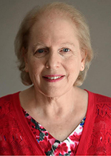

Description of planning process

Structural placement
Strategic planning at York County Community College is the administrative responsibility of the Associate Dean of Institutional Research & Planning as a member the College Leadership Team. Plan creation, maintenance, and evaluation falls within the purview of the Strategic Planning Committee, a standing committee of the College Council. The College Council continues to serve as the central governance entity for the institution and is comprised of student, staff, and faculty representatives. The College Council provides the forum for collegial discussion and debate and forwards recommendations of initiatives, planning, policies, practices, and procedures to the College President. The President maintains final approval for all College Council recommendations, including actions taken in regard to strategic planning. In addition to the College Council, the governance structure includes five Standing Committees consisting of Curriculum, Assessment, Health and Safety, Policy, and Strategic Planning.
Planning and evaluation processes at YCCC are guided in part by the Maine Community College System Strategic Plan, which comprises all seven public two-year community colleges in Maine and the MCCS System office. Although each college develops their own individual strategic plans, the System plan serves as a guide for goal setting at each constituent college, especially in the areas of enrollment growth and technological infrastructure. Additionally, it provides System benchmarks to measure achievements of plan goals and objectives. The 2015-2020 MCCCS Strategic Plan contains four goals to which the strategic goals of each college should be aligned. These goals are:
- Achieve student success through improved persistence, transfer, graduation, and employment performance.
- Support economic and workforce development.
- Invest in college classroom equipment, facilities, and programs.
- Maintain a high standard of accountability in all programs and services offered throughout the MCCS.

Recent planning history
The 2014-2019 YCCC Strategic Plan was accepted by the MCCS on February 6, 2014. At that time, the shared governance structure consisted of four Steering Committees concerned with strategic planning and four Standing Committees. The Steering Committees’ role in the monitoring and evaluation of the strategic plan was an area of concern mentioned in the 2014 New England Association of Schools & Colleges (NEASC) Five-Year Interim Report, and it became a focus for the College Council during the 2014/2015 academic year. After a period of deliberation and debate, a new committee structure was proposed and endorsed by the College Council and approved by the College President. This process follows the guidance of NEASC’s third Standard of Accreditation, which states “the institution’s organizational structure, decision-making processes, and policies are clear and consistent with its mission and support institutional effectiveness. The institution’s system of governance involves the participation of all appropriate constituencies and includes regular communication among them” (3.2). The new structure includes a Strategic Planning Standing Committee that is responsible for developing, revising, and evaluating the Strategic Plan. Consistent with all Standing Committees, this committee is made up of faculty, staff, and student representatives who are either assigned to the committee based on their job responsibilities or are elected to the committee by their peers. Committee recommendations are endorsed by the College Council and forwarded to the President for approval.
Recognizing a need for greater support of the strategic planning process, in April 2015 the President expanded the role of the Director of Institutional Research to include institutional planning. This position, now the Associate Dean of Institutional Research & Planning, serves as a permanent member on the Strategic Planning Committee and member of the Leadership Team. Also in April 2015, a Strategic Planning workshop was held on campus at YCCC to explore the topic of developing strategic college-wide goals. All employees were invited to attend and participate in the roundtable discussions and activities.
The Strategic Planning Standing Committee began its work during the 2015/2016 academic year. The first task of the committee was to review the current plan for progress and assess its continued viability. As a part of this review, the Academic Dean, Dean of Students and Dean of Finance and Administration reviewed the Strategic Directions and Actions to determine progress and continued relevance. This review revealed that progress had been made toward several of the objectives in the plan; however, several others needed revision, particularly those concerned with enrollment growth. At the end of the academic year, the committee presented five strategic goals to the College Council that will create the foundation for a revised strategic plan. These goals are more closely aligned with the new MCCS Strategic Plan, which focuses on student persistence and retention as compared to annual recruitment.
During the 2016/2017 academic year the Strategic Planning Committee developed a series of prioritized strategic actions and initiatives designed to support the revised goals finalized during the 2015/2016 academic year. The synthesis of the strategic actions and initiatives began with a campus-wide survey to gather potential content for this section of the plan and was followed by a community “Dot” exercise. This activity, held both on-campus and online, gathered feedback and captured relative support for the proposed actions and initiatives that were suggested by the community. The Strategic Planning Committee reviewed this information and finalized the strategic actions and initiatives based on both quantitative and qualitative feedback from the community “Dot” exercise participants, College Council members, and committee input as gathered from each of their representative constituents. The new objectives and measures we presented to the College Council in April 2017 and subsequently to College Leadership in June 2017.

Framing a plan

The YCCC 2017-2022 Five-Year Strategic Plan is comprised of five distinct sections, each building upon the foundation fortified by the sections that come before. First is the mission statement for the college; a clear and concise declaration that establishes the core purpose of York County Community College and lays a solid foundation to build upon. Second, the plan outlines a vision centered on student success, which forecasts the impact that the college intends to have over the course of the plan and beyond. Next the core values outline the moral and ethical principles through which the college mission will be upheld and the future vision achieved. At the core of the plan are the prioritized and attainable strategic goals, which will guide college initiatives and serve as benchmarking measures of the college’s evolving success throughout the life of the plan and summarily upon its expiration. Subsequently, the strategic actions and initiatives serve to flesh out the five major strategic goals, presenting the operational areas of the college with opportunities to meeting the plans objectives and community needs without specifically assigning work to either instructional or administrative individuals or departments at YCCC. Finally, the strategic measures outline a series of key data points that will be regularly examined to evaluate the relevance of the plan and the colleges ability to effectively meet the goals set forth by the plan.

Structure diagram of the plan

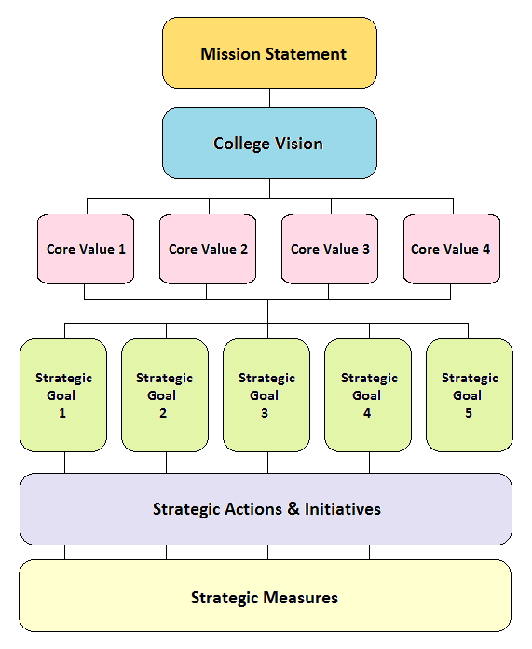

Planning groups and membership

College Leadership Team (6 individuals)
- Dr. Barbara Finkelstein – College President
- Paula Gagnon – Vice President & Academic Dean
- Jason Arey – Dean of Students
- Samuel Ellis – Dean of Finance & Administration
- Dr. Nicholas Gill – Associate Dean of Institutional Research & Planning
- Dr. Doreen Rogan – Associate Academic Dean

College Council constituents (11-14 individuals)
- Faculty: 3-5 members from full-time and adjunct faculty with 15+ annual credit hours of teaching elected by the Faculty Senate.
- College Leadership: 2 members of the senior administrative staff appointed by the College President.
- Staff: 5 members of the professional, technical, support, or confidential employees selected by an electoral process determined by the staff.
- Students: 1-2 part-time, full-time, matriculated or non-matriculated students selected by an electoral process determined by the Student Senate.

Strategic Planning Committee (8-9 individuals)
- 1 Academic Affairs representative, appointed by the Vice President & Academic Dean
- 1 Finance representative, appointed by the Dean of Finance & Administration
- 1 Student Affairs representative, appointed by the Dean of Students
- The Associate Dean of Institutional Research & Planning
- 2 Faculty members, appointed by the Faculty Senate
- 1-2 Staff-selected member(s), nominated and elected by their peers
- 1 Student representative, a volunteer from the current student body

Mission
York County Community College provides academic, career, and transfer programs while serving to advance cultural, economic, and workforce development in York County and the State of Maine.

Vision
At York County Community College, we celebrate each student’s individual success. While we recognize academic progress as an important part of their journey, we appreciate the value of life experience, personal development, self-awareness and the pursuit of learning.

Connections and individual attention are at the heart of our relationships with students. Whether they spend a semester or several years at our college, students will leave knowing they have been part of a community that has invested in them as a whole person. We are committed to empowering each student to achieve their full academic potential and accomplish their personal goals.

Core Values

Accountability
We are responsible to our community and we consider the impact of our actions and decisions through transparency and inclusion.

Innovation
We promote curiosity and discovery by supporting continuous growth with particular emphasis on new educational strategies, emerging technologies, and organizational development.

Cooperation
We value collaboration through mutual contribution and collective efforts by combining the talents, experience, and skills of the College community.

Empowerment
We appreciate and value the inherent potential of our community and YCCC makes a conscious commitment to assist people in achieving their academic, personal and professional goals through intellectual engagement.

Strategic Goals

I. Pursue educational excellence by promoting and measuring student success in all forms.
(i.e. capturing intent of the individual and tracking the progression and/or changes in that intent via improved persistence, graduation, transfer, engagement, employment etc.)

Actions and initiatives:
- Develop course schedules that allow students to meet their educational goals, including graduation, transfer, employment, or enrichment.
- Examine student feedback and review course success rates to assess academic effectiveness and format preferences (i.e. classroom, online, hybrid).
- Increase course sequence planning and program tracks to ensure that pathways to student success are maximized within the confines of YCCC’s resources.
- Expand on efforts to promote student literacy and numeracy such as increasing student outreach resources and assessing placement practices.

II. Enhance collaboration and strengthen connections to meet community needs.
(i.e. targeted marketing, increased visibility, and diverse/innovative programming)

Actions and initiatives:
- Explore options for assisting students with childcare obstacles, such as partnerships with regional childcare facilities or an on-site service that could integrate credit programming.
- Promote and offer more wellness and physical activities.
- Promote business and community outreach to respond to emerging employment deficits and needs.
- Expand counseling and wellness services to provide support groups, targeted wellness activities, and outreach for non-traditional students.

III. Maintain and advance our technological and physical infrastructures to meet the needs of the college community
(i.e. create long-term renovation plan, implement technology fee structure)

Actions and initiatives:
- Establish a capital improvements budget to support the regular maintenance, repair, and updating of all physical plants, starting with the 2017-2018 annual budget
- Enhance the Information Technology (IT) budget to support more regular maintenance and upgrading of the College’s technological infrastructure, starting with the 2017-2018 annual budget.
- Prioritize funding for additional professional staff with skills set specifically aimed at supporting the operations of the physical plant, technological infrastructure, and database management.
- Develop an integrated community feedback system for communicating areas of need and increased support with the Information Technology and Facilities staff and leadership.

IV. Continually assess and improve accountability and resource stewardship focused on efficiency and effectiveness.
(i.e. proactive budgeting, categorical finances, procurement processes, regulatory compliance, OPEGA)

Actions and initiatives:
- Explore procedural and technological options to allow students more flexibility in how they acquire their textbooks, vouchers, and other qualified academic resources.
- Conduct regular process and initiative assessments at the College to evaluate the effectiveness of intra-institutional operations, services, and administration.
- Prioritize funding for professional staff and faculty by using evidence produced through assessment and evaluation as it related to institutional effectiveness.
- Establish an internal resource network that would allow for cross-institutional support amongst administrative and instructional departments.

V. Foster innovation by investing in and empowering our employees.
(i.e. continuing education, training, recognition program, and professional development)

Actions and initiatives:
- Establish a consistent, institutional framework that allows all YCCC employees access to professional development funding in accordance with Collective Bargaining Agreements and/or established policy.
- Offer more regular, free, onsite, professional development opportunities for all staff & faculty.
- Establish an internal knowledge network that would allow for the sharing of knowledge through peer presentations and/or a blog.
- Develop awareness of the processes that allow YCCC employees to utilize grants to fund professional development opportunities and assist with application processes.

Strategic Measures

The College Leadership Team and Strategic Planning Committee commit to reviewing and benchmarking the college’s success in working towards and meeting our strategic goals through continuous review of data and metrics through the following means:

- Promoting the “A New Path Forward: Achieving the Dream” philosophy as a means for catalyzing a culture of evidence, continuous evaluation, and comprehensive assessment to better monitor institutional effectiveness and student success.
- Examining CCSSE (Community College Survey of Student Engagement) results for the number/percent of students who rate the college highly for “support for learners”.
- Explore using student course evaluations and measuring the number/percent of respondents who rate courses highly based on measures of interaction, engagement, and relevance as a source of qualitative insight.
- Examining data that measures the number/percent of new students who are ready to take college classes after their first semester, including by not limited to: High School GPA, SAT, ACT, placement test scores, and Developmental Education course performance
- Using a climate survey to annually measure the number/percent of employees who report “satisfaction in the workplace” and engagement in professional development.
- Measuring the alignment of student success with institutional effectiveness through quantifying the following metrics:
          - First-time YCCC students who persist from Fall to Spring and Fall to Fall.
          - Predictive and reactive retention metrics.
          - YCCC Students who graduate/complete at YCCC (IPEDS, MCCS, College Board).
          - YCCC Students who transfer (NSC).
          - Full Time Equivalent (FTE) enrollment, headcounts, and total credits (IPEDS, MCCS, NSC).
          - National board and/or competency exams that are administered at the time of or immediately following program completion.
          - YCCC graduates who are employed within a year of graduation (MDOL, MCCS).
- Documenting and comparing employer partners and collaborating institutions who report satisfaction with YCCC’s program relevance and rigor with advisory boards, internship sites, and BCP training partners.

