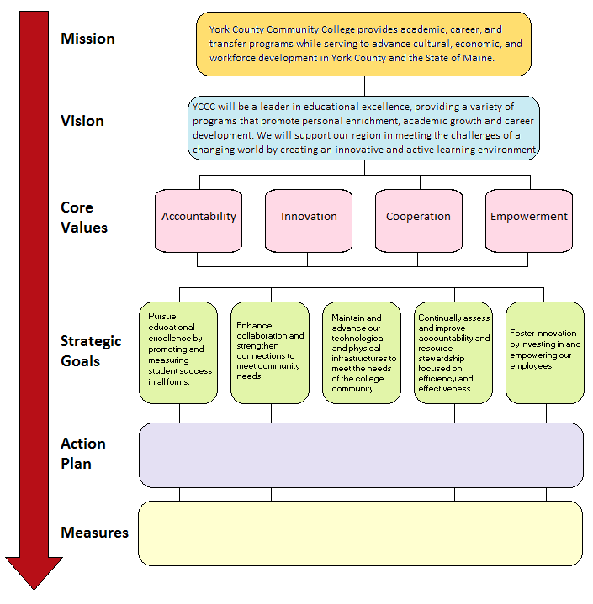

Adapted from:

A Practical Guide to Strategic Planning in Higher Education, by Karen E. Hinton
© 2012 Society for College and University Planning - www.scup.org

