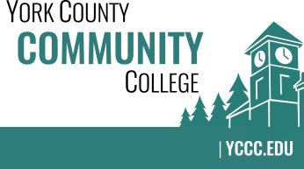

Strategic Planning Committee
Thursday: March 21, 2019
10:00 – 11:30 in the Clocktower Conference Room

AGENDA

1. Call to order and roll call

2. Review and approval of agenda

3. Updates
3.1 Welcome new Adjunct Faculty member Jennifer Healy
3.2 Welcome new Staff member Kristen Weigand

4. Old business
4.1 None

5. New business
5.1 Discuss and finalize alignment between YCCC Strategic Plan and MCCS Strategic Work Plan (D, A)
5.2 Discuss 2019-2020: Assessment of plan effectiveness and use

6. Announcements

7. Public Comment

8. Adjournment

Note: In keeping the College Council’s Agenda practices, agenda items are coded as follows:
A= Action Item; C= Committee Report; D= Discussion; I= Information

