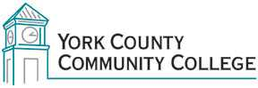

Program Learning Outcomes Students who successfully complete the Associate in Applied Science in Trade and Technical Occupations will be able to:

- Recognize and apply appropriate terminology within the chosen trade or technical occupation.
- Describe ethical and responsible behavior relative to the chosen technical occupation.
- Recognize the value of diversity in opinions, values, abilities, and cultures of colleagues and customers in a professional workplace.
- Apply problem-solving skills and quantitative analysis using technology relative to the trade or technical occupation.
- Utilize appropriate information resources to gather and disseminate technical information within the chosen trade.
- Demonstrate effective written and verbal communication skills in a variety of professional settings.

