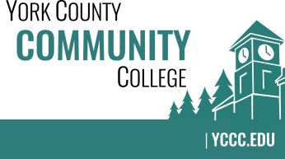

Strategic Planning Committee
Wednesday: October 25, 2017
3:00 – 4:00 in the Clocktower Conference Room

AGENDA

1. Call to order and roll call

2. Approval of meeting notes from Meeting #6 (4/25/2017)

3. Review and approval of agenda

4. Updates
4.1 ATD / Core Team Work
4.2 NEASC 10 Year Reaccreditation – Standard 1 (Mission & Purpose) and Standard 2
(Planning & Evaluation)

5. Old business

6. New business
6.1 Review complete draft of new Strategic Plan (D, A)
6.2 Accept student success statement as the new Vision
6.3 How does ATD fit in? Strategic Measures
6.4 Other issues, goals, or questions

7. Announcements

8. Public Comment

9. Adjournment

Note: In keeping the College Council’s Agenda practices, agenda items are coded as follows: A= Action Item; C= Committee Report; D= Discussion; I= Information

