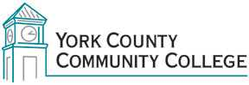

College Council
Tuesday: October 6th, 2015
12:30 – 2:00 in the Middle Cafeteria

AGENDA

1. Call to Order

2. Approval of Agenda

3. Approval of Minutes

4. Updates
4.1 President’s Update (I)
4.2 Master Planning Ad-Hoc committee (C)
4.3 Building Ad-Hoc committee (C)
4.4 Standing Committee reports (C)

5. Old Business
5.1 Edited bylaws Strategic Planning Committee (I)

6. New Business
6.1 Online Collection of CC Documents – working group? (D, A)
6.2 New AAS Hospitality (and Tourism) Management (D)
6.3 MCCS Computer Acceptable Use Policy (I)
6.4 Vice Chair Election (D, A)

7. Announcements

8. Public Comment

9. Adjournment

Note: In keeping the College Council’s Agenda Item Request Form, agenda items are coded as follows: A= Action Item; C= Committee Report; D= Discussion; I= Information

