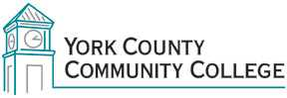

College Council
Tuesday: 6 March 2018
12:30 – 2:00 in the Mid-Cafe

AGENDA
1. Call to Order/Roll Call

2. Approval of Minutes of previous meeting

3. Approval of Agenda

4. Reports of officers
4.1 President’s Report (I)

5. Reports of Standing Committees
5.1 Strategic Planning Committee (C)
5.2 Policy Committee (C)
5.3 Curriculum Committee(C)
5.4 Assessment Committee (C)
5.5 Health & Safety (C)

6. Reports of ad hoc committees
6.1 Cornerstones of Governance Survey update (I)

7. Public Comment

8. Unfinished Business

9. New Business
9.1 Annual Policy Audit items (D)
9.2 Termination Policy & Procedure (D)
9.3 “Active Shooter” on campus (D)

10. Announcements

11. Adjournment
Note: In keeping the College Council’s Agenda Item Request Form, agenda items are coded as follows: A= Action Item; C= Committee Report; D= Discussion; I= Information

