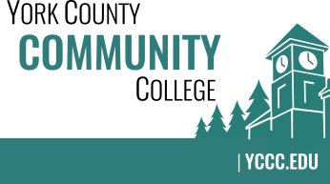

Strategic Planning Committee
Thursday: March 2, 2017
11:00 – 12:15 in the Community Board Room (Dr. Charlie Lyons Board Room)

Strategic Planning Members (☒: indicates attendance)

☒ Nicholas Gill (Chair)
☒ Cathleen Ferrick
☒ Brittany Heaward
☒ Margaret “Peg” Wheeler
☒ Audrey Gup-Mathews
☒ John Hall
☒ Paul Gurney (committee recorder)
☐ Samuel Ellis
☒ Melinda Gilliam

1. Call to order and roll call
- Meeting called to order at 11:08 a.m.

2. Approval of meeting notes
- Approve as amended

3. Review and approval of agenda
- Agenda presented by Nicholas Gill (Chair) and accepted by a unanimous vote of the committee members present.

4. Updates
4.1 Review the update given to Dr. Finkelstein for NEASC visit follow-up
- Barbara and Paula going to NEASC debriefing Nick providing SPC info composition of group and electronic access to SPC information and community involvement. The results of the DOT exercise and our work will be discussed @ NEASC on Friday

4.2 Short article in “YCCC Happenings” March edition
- Our committee info is in the March edition with a DOT exercise update.

4.3 Present full “dot exercise” results at March 7th College Council meeting
- Nick will do a full presentation of the DOT exercise at the 3/7 CC meeting.

5. Old business

6. New business
6.1 Share / peer edit break-out group draft language plan (D, A)
  - The member(s) of the committee presented their responses to the specific questions listed regarding actions/Initiatives and our strategic goals. Each member who provided answers will provide the electronic documented answers to Nick.
6.2 Look at additional actions/initiatives to include (D, A)
  - Nick will review information provided, email compiled responses to questions to the members of the SPC, and provide next step(s).

7. Announcements

8. Public Comment

9. Adjournment
- 12:20pm

Note: In keeping the College Council’s Agenda practices, agenda items are coded as follows: A= Action Item; C= Committee Report; D= Discussion; I= Information

