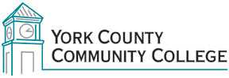

Assessment Committee
Thursday: November 17, 2016
12:30 – 2:00
Clocktower

The committee met to continue the work on the communication project. There was no agenda or business conducted.

