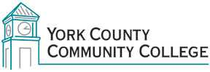

College Council
Tuesday: May 2nd, 2017
12:30 – 2:00 in the Middle Cafeteria

AGENDA
1. Call to Order

2. Approval of Agenda

3. Approval of Minutes

4. Updates
4.1 President’s Update (I)
4.2 Strategic Planning Committee (C)
4.3 Policy Committee (C)
4.4 Standing Committee reports (C)
4.5 College Council Chair (I)

5. Old Business
5.1 Student Success Statement (A)
5.2Animals on Campus (A)

6. New Business

7. Announcements

8. Public Comment

9. Adjournment

Note: In keeping the College Council’s Agenda Item Request Form, agenda items are coded as follows: A= Action Item; C= Committee Report; D= Discussion; I= Information

