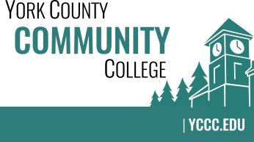

Strategic Planning Committee
Thursday: November 17, 2016
9:00 – 10:00 in the Clocktower Conference Room

AGENDA

1. Call to order and roll call

2. Approval of meeting notes from Meeting #2 (11/10/2016)

3. Review and approval of agenda

4. Updates
4.1 Welcome Melinda Gilliam as the 2016-2017 student representative on the committee
4.2 Status of a possible locker room in the new Academic building
4.3 Overview of efforts to promote the “Actions & Initiatives” online survey
4.4 Results (quantitative yield) from the survey (it is very good!)

5. Old business

6. New business
6.1 Review grouped feedback and raw data from the survey (D)
6.2 Discuss a good time for a community in-person “dot” exercise (A)
6.3 Should it have an open ended component? (D, A)

7. Announcements

8. Public Comment

9. Adjournment

Note: In keeping the College Council’s Agenda practices, agenda items are coded as follows: A= Action Item; C= Committee Report; D= Discussion; I= Information

