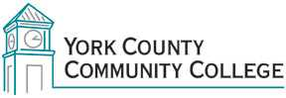

College Council
Tuesday: April 5th, 2016
12:30 – 2:00 in the Middle Cafeteria

AGENDA
1. Call to Order

2. Approval of Agenda

3. Approval of Minutes

4. Updates
4.1 President’s Update (I)
4.2 Strategic Planning Committee (C)
4.3 Policy Committee (C)
4.4 Standing Committee reports (C)

5. Old Business
5.1 Proposed Amendment to Constitution – Alumni representation (A)
5.2 Y111 Governance Policy – Updated (D, A)
5.3 Y112 Organizational Chart – Updated (D, A)
5.4 Y713.1.A Mobile Device Policy – Updated (D,A)

6. New Business
6.1 American Studies Concentration (D)

7. Announcements

8. Public Comment

9. Adjournment

Note: In keeping the College Council’s Agenda Item Request Form, agenda items are coded as follows: A= Action Item; C= Committee Report; D= Discussion; I= Information

