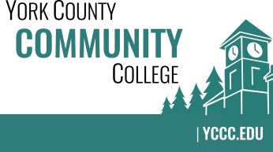

Strategic Planning Committee
Wednesday: November 28, 2018
9:00 – 10:00 in the Clocktower Conference Room

AGENDA

1. Call to order and roll call

2. Review and approval of agenda

3. Updates
3.1 None

4. Old business
4.1 None

5. New business
5.1 Review of meeting with Dr. Finkelstein (D)
5.2 Review of current YCCC Departmental Plans and discussion of template components (D)

6. Announcements

7. Public Comment

8. Adjournment

Note: In keeping the College Council’s Agenda practices, agenda items are coded as follows: A= Action Item; C= Committee Report; D= Discussion; I= Information

