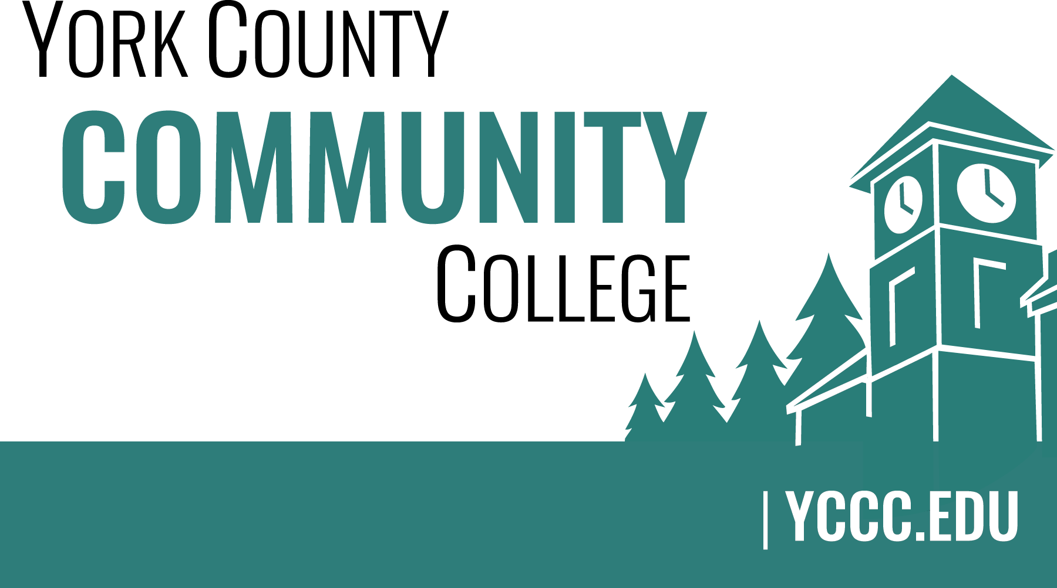

YCCC Strategic Planning 2016-2017
Meeting Notes, January 26, 2017 (DRAFT)

Strategic Planning Members (☒: indicates attendance)

☒ Nicholas Gill (Chair)
☒ Cathleen Ferrick
☒ Brittany Heaward
☒ Margaret “Peg” Wheeler
☒ Audrey Gup-Mathews
☐ John Hall
☒ Paul Gurney (committee recorder)
☒ Samuel Ellis
☒ Melinda Gilliam

1. Call to order and roll call
- Meeting to order at 2:05 PM

2. Approval of meeting notes
- Approved as presented.

3. Review and approval of agenda
- Agenda presented by Nicholas Gill (Chair) and accepted by a unanimous vote of the committee members present.

4. Updates
4.1 Online version “Dot” Exercise results integrated with December 2016 event data
- Nick shared the results with the group and the committee concurred that the online “Dot” exercise aligned well with the one done during the day on campus.

4.2 Short article in “YCCC Happenings” February edition.
- Nick informed the group that there is a short article titled “Strategic Planning committee”. The article thanks those who participated in the DOT exercise and shared the results.

4.2 Presentation at College Counsel in February 2017…
- Nick plans to present the top 5 to 10 items highlighting student data and field questions. The goal is to provide transparency…

4.3 Host results on YCCC Portal. All results are to go on the portal.

5. Old business
- None

6. New business

6.1 Brainstorm: How will we ingrate feedback into actions in the emerging plan (D)
- Childcare: Expensive to integrate, student coop could reduce costs. What would be our liability? Is there space here for a coop? Who will manage and enforce rules for the childcare? Grant funding may be available for outside daycares. It may be wise to visit other colleges to find out how they are meeting this challenge. The SPC needs to deliver messages, generalized, and not concentrate on the how but be directional. Someone else will have to apply the operational expertise needed to bring this to fruition.
- Student progress: A full time advisor is appropriate for monitoring student progress. Where does the money for that come from? This should be a priority hiring more of a qualitative advisor than quantitative. Students have not had their needs met in this area due to cuts in spending. This has left the college with many different types of advisors from various sources but not working together. The Student Navigator system is difficult to tell if it helps. For student success, all advisors must communicate and be on the same page. A registrar’s office is necessary to centralize advising and increase collaboration.
- Actions/Initiatives and our strategic goals: SPC received a handout, which has a list of five categories with a list of actions from the DOT exercise in each (page 3 of handout). The SPC will split into mini committees and continue brainstorming the initiatives as they pertain to the strategic goals (See attachment for grouping).

6.2 Create a timeline for the rest of 2017 (D)
- The SPC will get together by the end of February to share sub group information and if necessary add other to sub groups.

7. Announcements
- Peg met with Kate Hanson; Insurance Company we utilize may have Wellness incentives.

8. Public Comment
- None

9. Adjournment
  - Meeting adjourned by Nicholas Gill at 3:07 PM

