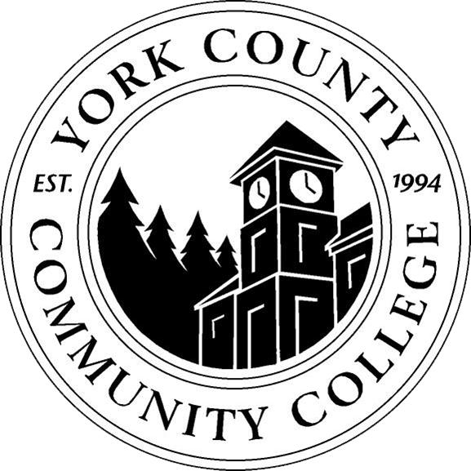

YCCC Strategic Planning 2015-2016:
Meeting Notes, November 24, 2015
Record by Nicholas Gill, Associate Dean of IR & Planning

1. Call to order and roll call
- Meeting called to order by Nicholas Gill at 10:04AM
- Committee members in attendance: Nicholas Gill, Tami Gower, Audrey Gup-Mathews, Brittany Heaward, Angela Nadeau, Maria Niswonger, Dana Petersen.
- No committee members were absent, except the non-appointed student representative
- Community members in attendance: Cindy Lahar, Dianne Fallon, David Susman, Amber Tatnall

2. Approval of minutes - deferred (first meeting of the new committee)

3. Review and approval of agenda - approved unanimously
- Tami Gower asked for clarification as to the institutional role of the Associate Dean of IR & Planning and how that role balances against the governance structure and College Counsel’s duties for the committee.
- Nicholas Gill highlighted that administratively and structurally the responsibility of developing, publishing, and maintaining the YCCC Strategic Plan falls to his position in YCCC’s leadership structure. However, the process through which the plan is created and rectified remains in governance in the form of the Strategic Planning Committee. The Associate Dean (Nicholas Gill) is effectively a dialectic liaison between the committee and institutional leadership communicating both the progress of the planning process to college leaders and bringing the goals and charges of leadership regarding planning to the committee.

4. No updates (first meeting of the new committee)

5. Old business was deferred (first meeting of the new committee)

6. New Business:
- 6.1 Election of chairperson
  - Dana Petersen nominated Nicholas Gill as the chairperson for the 2015-2016 Strategic Planning Committee.
  - Tami Gower seconded the nomination.
  - Vote: 6 in favor, 1 abstain (Nick Gill)
- 6.2 Appointment of note taker via Dr. Finkelstein
  - Nicholas Gill relayed that Dr. Finkelstein is unable to appoint a note taker for the committee, and suggested that they elicit a volunteer or self-appoint one of the committee members to take notes for the meeting minutes.
  - Tami Gower stated that a note taker is assigned for other committees such as Faculty management, Curriculum, and Assessment committees at YCCC. It is not appropriate to have a voting member of the committee take notes because it takes them away from the conversation and impacts the quality of minutes recorded.
  - Tami Gower Also stated that leadership’s not appointing a note taker does not support the validity of the committee and their buy in to the importance of their work.
  - Nicholas Gill promised to relay the committee’s stance to the College President. Additionally, he suggested that the committee try to recruit a volunteer note taker at the December College Counsel meeting, the committee concurred that this would be a good first line of action.

- 6.3 Review of Strategic Planning Committee bylaws
  - Angela Nadeau asked the chair to clarify the “Scope of Work” as established in the committee bylaws, specifically relating to subsection b: “Ensure broad-based input from and communication with the campus community.” Additionally, she wanted to know how the committee’s authority was structured, is this group given directives and just tasked with carrying out leadership’s work for them, or do they have the authority to build and change the plan.
  - Nicholas Gill attempted to clarify that the committee’s authority is in between complete autonomy and directive-driven. The goals and charges distributed through the President’s office are designed to be directional and catalyze forward momentum, but are not exclusive of other work the committee can and will accomplish.
  - Maria Niswonger and Angela Nadeau both requested that Dr. Finkelstein by invited to the next meeting to discuss her charge for the group.

- 6.4 Review of Committee Goals from Dr. Finkelstein through Associate Dean Gill
  - The group discussed the two specific goals of realigning YCCC enrollment growth with institutional and MCCS objectives and streamlining the eight current directions and actions contained in the YCCC plan.
  - There was an engaging discussion about the nature of enrollment and how credits and seats, combined with other metrics make the concept of growth much larger than simple comparative headcounts.
  - Tami Gower suggested that the group attempt to locate previous community-wide exercises like the “Dots Exercise” from 2013, the Aslanian Market Analysis, and other surveys / data constructs that went into formulating our current mission, vision and core values in the YCCC plan. Any documents that are public will be posted on the committee portal page.

- 6.5 Review of “Aligning 2014-2019 YCCC ‘Directions and Actions’ with the MCCS” document submitted by the Associate Dean of IR & Planning
  - Angela Nadeau proposed that the committee begin to gather real enrollment data to chart the changes and progress in YCCC student demographics and makeup as a basis for building a new set of enrollment goals for the college. Additionally she proposed that the current table with enrollment statics be removed as the committee works to rectify the plan.
  - Tami Gower indicated that this work in very important but the plan goes through several levels of approval before it can be posted, thus the current plan probably can’t be taken down in pieces.
  - Nicholas Gill concurred that the current YCCC Strategic Plan is our published document until we have amendments drafted by the committee, approved by College Counsel, recommended/approved by Dr. Finkelstein, and finally sanctioned by the MCCS Board and leadership.
  - Tami Gower proposed that the committee give the current plan with all of the Directions and Actions back to the Deans for a progress report about what is being realized, what has been omitted, and what may have been added. This information could be used at the next meeting as a basis for consolidating the current Directions and Actions into a more manageable list of goals.
  - The committee did not vote on this action, but collectively did agree that such information would be extremely useful. The Associate Dean will prepare and distribute and assessable version of the “Directions and Actions” to the Deans for self-evaluation.

- 6.6 Begin to restructure Goal #2 to align with MCCS Strategic Plan – deferred / covered in previous New Business agenda topics.

7. Announcements
- Maria Niswonger asked the group to consider when a good time would be to meet starting when the faculty members arrive back on campus in January 2016.
- Nicholas Gill stated that the day and times best suitable would be driven first by the faculty membership, since the administrative staff have updated Outlook Calendars through which the group can coordinate a time around course schedules.
- Dana Petersen agreed that the scheduling should start with faculty availability
- Brittany Heaward suggested Fridays since they are relatively light compared to other days of the week regarding class schedules, this could also help our pending student representative.
- Angela Nadeau asked the chair to request a student representative from student senate.
- Nicholas Gill responded that student activities administration has been asked to solicit a student representative but has not been successful. Nick will reach out through Brianne Ryan (Student Senate) directly to see about recruiting a voting participant

8. Public Comment – None

9. Adjournment
  - Motion to adjourn made by Nicholas Gill
  - Motion seconded by Tami Gower
  - Unanimous vote, meeting concluded at 11:09pm

