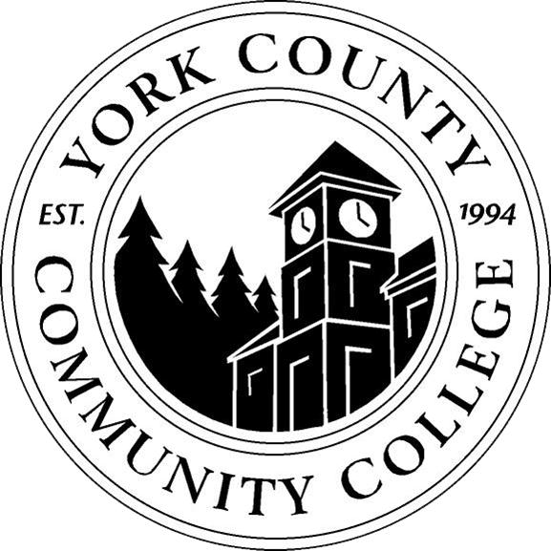

YCCC Strategic Planning 2015-2016:
Aligning 2014-2019 YCCC “Directions and Actions” with the MCCS

A. Connecting Previous and Current MCCS Strategic Planning (SP) Goals

# | Current MCCS SP Goals | Corresponding Previous MCCS SP Goals
1 | Achieve student success through improved persistence, transfer, graduation, and employment performance. | G3: Increase student success  G4: Expand transfer opportunities for students, into and out of, the colleges of the MCCS
2 | Support economic and workforce development. | G6: Support economic development
3 | Invest in college classroom equipment, facilities, and programs | G1: Enhance quality at each institution
4 | Maintain a high standard of accountability in all programs and services offered throughout the MCCS | G5: Maintain a strong higher education presence in rural Maine

Previous G2: Increase system enrollment to 20,500 by 2018: OMITTED FROM MCCS GOALS

B. Aligning YCCC “Directions and Actions” with MCCS Goals

Alignment? | YCCC SP “Directions and Actions”
√ | Pursue educational excellence
√ | Promote student success and engagement
Needs Work | Promote enrollment growth and access
√ | Expand career and workforce development programs
√ | Ensure resource stewardship and financial stability
√ | Develop appropriate technology to support growth
√ | Develop campus physical environment to support growth
√ | Promote community outreach

Promote enrollment growth and access:
Goal was to increase credit enrollment at YCCC by 50%, this should be scaled back, however some growth is still an YCCC internal goal as evidenced by the pending construction of our new academic building

YCCC Strategic Planning 2015-2016:
Strategic Planning Committee Membership

Name | Documented Position
Angela Nadeau | Academic Affairs representative, appointed by the Vice President/Dean of Academic Affairs
Dana Petersen | Finance representative, appointed by the Dean of Finance
Brittany Heaward | Student Affairs representative, appointed by the Dean of Students
Nicholas Gill | Associate Dean of Institutional Research and Planning
Tami Gower | Faculty Representative
Maria Niswonger | Faculty Representative
VACANT | Staff-selected Representative
VACANT | Student Representative

SPC Calendar:

The Chair of College Counsel (John Hall) will be putting out a call for the Staff-selected Representative now that the Dean-appointed members have been chosen.

The first meeting of the YCCC Strategic Planning Committee will be in mid-November to review the YCCC “Directions and Actions” in perspective of the MCCS SP Goals and Internal YCCC initiatives (i.e. new academic building)

