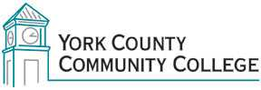

College Council: (years remaining on current term in parentheses)

2018/2019 Roster

Administrative:

Barbara Finkelstein (ex officio)
Jason Arey (1 yr)
Paula Gagnon (2 yr)

Faculty:

Heather Lewis (ADJ) (2 yr)
Joan Ludwig (ADJ) (1 yr)
Tom McGinn (FT) (1 yr)
Maria Niswonger (FT) (1 yr) Chair
Peg Wheeler (FT) (2 yr)

Staff:

Claudette Dupee (2 yr)
Jane Kimball Foley (2 yr) Vice-chair
Audrey Gup-Mathews (2 yr)
Brittany Heaward (1 yr)
Maureen Michaud (1 yr)

Student Representative:

Jenna Cole (1 yr)
Michael Oliver (1 yr)

