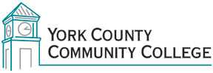

College Council
Tuesday: November 3rd, 2015
12:30 – 2:00 in the Middle Cafeteria

AGENDA

1. Call to Order

2. Approval of Agenda

3. Approval of Minutes

4. Updates
4.1 President’s Update (I)
4.2 Master Planning Committee (C)
4.3 Building Ad-Hoc committee (C)
4.4 Strategic Planning Committee (C)
4.5 Policy Committee (C)
4.4 Standing Committee reports (C)

5. Old Business

6. New Business
6.1 New AAS/Certificate Gerontology
6.2 Online Documentation Work Group Proposal (D, A)
6.3 Display Policy (D, A) *appropriate for new policy committee, not formed yet

7. Announcements

8. Public Comment

9. Adjournment

Note: In keeping the College Council’s Agenda Item Request Form, agenda items are coded as follows: A= Action Item; C= Committee Report; D= Discussion; I= Information

