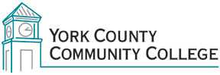

College Council: (years remaining on current term in parentheses)

2017/2018 Roster

Administrative:

Barbara Finkelstein (ex officio)
Jason Arey (2 yr)
Sam Ellis (1yr)

Faculty:

Joan Ludwig (FT) (2 yr)
Maria Niswonger (FT) (2 yr)
Tom McGinn (FT) (2 yr)
Peg Wheeler (FT) (1 yr)
John Hall (ADJ) (1 yr)

Staff:

Vacant (2 yr)
Maureen Michaud (2 yr)
Paul Archer (1 yr) Chair
Claudette Dupee (1 yr)
Audrey Gup-Mathews (1 yr)

Student Representative:

Jenna Cole (1 yr)
Michael Oliver (1 yr)

