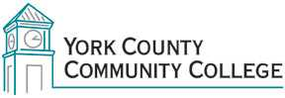

College Council
Tuesday: December 1st, 2015
12:30 – 2:00 in the Middle Cafeteria

AGENDA
1. Call to Order

2. Approval of Agenda

3. Approval of Minutes

4. Updates
4.1 President’s Update (I)
4.2 Master Planning Committee (C)
4.3 Building Ad-Hoc committee (C)
4.4 Strategic Planning Committee (C)
4.5 Policy Committee (C)
4.4 Standing Committee reports (C)

5. Old Business
5.1 Amend Constitution to replace Steering Committees (D, A)
5.2 Ask committees to amend bylaws for online documentation policy? (D, A)

6. New Business
6.1

7. Announcements

8. Public Comment

9. Adjournment

Note: In keeping the College Council’s Agenda Item Request Form, agenda items are coded as follows: A= Action Item; C= Committee Report; D= Discussion; I= Information

