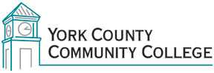

Strategic Planning Committee
Tuesday: January 26th, 2016
1:00 – 2:30 in the Clocktower Conference Room

AGENDA

1. Call to order and roll call

2. Approval of minutes from November 24, 2015

3. Review and approval of agenda

4. Updates

5. Old business – deferred
5.1 Appointment of note taker via Dr. Finkelstein (I)

6. New business
6.1 Review “Directions and Actions Dean’s Inventory” results (D)
6.2 6.2 Review articles highlighting potential student populations and demographics (I)
6.3 Examine Data: Master Planning Survey results (D)
6.4 Examine Data: Aslanian Market Research Summary (D)
6.5 Review “Goal Alignment” concept for February 9, 2016 meeting (I)

7. Announcements

8. Public Comment

9. Adjournment

Note: In keeping the College Council’s Agenda practices, agenda items are coded as follows: A= Action Item; C= Committee Report; D= Discussion; I= Information

