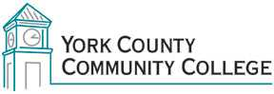

Medical Assisting A.A.S.
Program Learning Outcomes Upon successful completion of the Associate of Applied Science Degree in Medical Assisting, graduates will be able to:
- Recognize and apply appropriate medical terminology in a variety of healthcare situations to ensure safe and effective patient care
- Perform essential administrative skills to ensure efficient operations within a medical office
- Provide general patient care services with respect for differences in age, class, gender, culture, and/or sexual orientation
- Apply principles of safety to all aspects of patient care and clinical procedures
- Locate current ethical and legal standards of care and analyze their impact on healthcare services and operations
- Perform essential clinical skills and follow diagnostic procedures in laboratory settings

