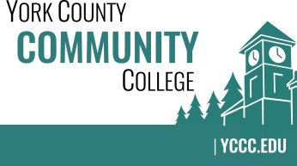

Strategic Planning Committee
Wednesday: October 24, 2018
9:00 – 10:00 in the Clocktower Conference Room

AGENDA

1. Call to order and roll call

2. Review and approval of agenda

3. Updates
4.1 Dashboard Data (ATD) – Fall Enrollment
4.2 NEASC – Standard 1 (Mission & Purpose) and Standard 2 (Planning & Evaluation)

5. Old business
5.1 None
6. New business
6.1 Department Plans – draft guidelines or template (D, A)
6.2 Meeting times – November

7. Announcements

8. Public Comment

9. Adjournment

Note: In keeping the College Council’s Agenda practices, agenda items are coded as follows: A= Action Item; C= Committee Report; D= Discussion; I= Information

