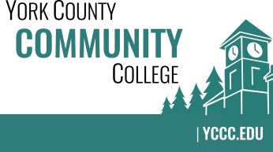

Strategic Planning Committee
Thursday: December 15, 2016
9:00 – 10:00 in the Clocktower Conference Room

AGENDA

1. Call to order and roll call

2. Approval of meeting notes from Meeting #3 (11/17/2016)

3. Review and approval of agenda

4. Updates
4.1 Two-day on-campus dot exercise received great results and reviews
4.2 Comments from dot exercise
4.3 Online version active for one-week

5. Old business

6. New business
6.1 Review preliminary results from dot exercise (D)
6.2 Discuss thoughts around where we are and where we are going (D)

7. Announcements

8. Public Comment

9. Adjournment

Note: In keeping the College Council’s Agenda practices, agenda items are coded as follows: A= Action Item; C= Committee Report; D= Discussion; I= Information

