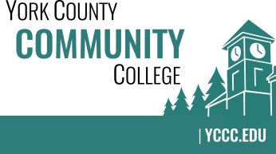

Strategic Planning Committee
Thursday: January 26, 2017
2:00 – 3:30 in the Clocktower Conference Room

AGENDA

1. Call to order and roll call

2. Approval of meeting notes from Meeting #4 (12/15/2016)

3. Review and approval of agenda

4. Updates
4.1 Online version “Dot” Exercise results integrated with December 2016 event data
4.2 Short article in “YCCC Happenings” February edition
4.2 Presentation at College Counsel in February 2017…
4.3 Host results on YCCC Portal?

5. Old business

6. New business
6.1 Brainstorm: How will we ingrate feedback into actions in the emerging plan (D)
6.2 Create a timeline for the rest of 2017 (D)

7. Announcements

8. Public Comment

9. Adjournment

Note: In keeping the College Council’s Agenda practices, agenda items are coded as follows: A= Action Item; C= Committee Report; D= Discussion; I= Information

