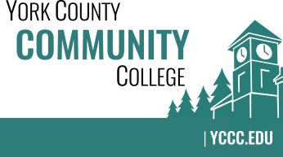

Strategic Planning Committee
Thursday: October 13, 2016
9:00 – 10:00 in the Clocktower Conference Room

AGENDA

1. Call to order and roll call

2. Approval of meeting notes – N/A (last meeting was a working session)

3. Review and approval of agenda

4. Updates
4.1 Note taker in accordance with Article V, Section 2 (Paul Gurney, Business Manager)
4.2 Achieve the Dream – What is it? How will it fit in?
4.3 Share collaterals to be shared with NEASC team

5. Old business

6. New business
6.1 Meeting scheduling, what works best? (A)
6.2 Chairperson selection (A)
6.3 Overview of Strategic Plan structure (D)
6.4 Review 5 Strategic Goals from 2015-2016 work (D)

7. Announcements

8. Public Comment

9. Adjournment

Note: In keeping the College Council’s Agenda practices, agenda items are coded as follows: A= Action Item; C= Committee Report; D= Discussion; I= Information

