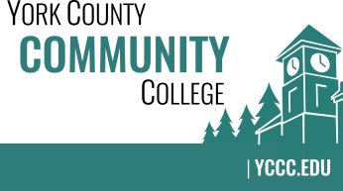

Strategic Planning Committee
Thursday: March 2, 2017
11:00 – 12:15 in the Community Board Room (Dr. Charlie Lyons Board Room)

AGENDA

1. Call to order and roll call

2. Approval of meeting notes from Meeting #5 (1/26/2017)

3. Review and approval of agenda

4. Updates
4.1 Review the update given to Dr. Finkelstein for NEASC visit follow-up
4.2 Short article in “YCCC Happenings” March edition
4.3 Present full “dot exercise” results at March 7th College Council meeting

5. Old business

6. New business
6.1 Share / peer edit break-out group draft language plan (D, A)
6.2 Look at additional actions/initiatives to include (D, A)

7. Announcements

8. Public Comment

9. Adjournment

Note: In keeping the College Council’s Agenda practices, agenda items are coded as follows: A= Action Item; C= Committee Report; D= Discussion; I= Information

