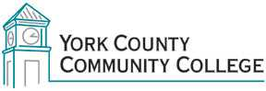

College Council
Tuesday: 7 November 2017
12:30 – 2:00 in the Middle Cafeteria

AGENDA
1. Call to Order

2. Approval of Agenda

3. Approval of Minutes

4. Updates
4.1 President’s Update (I)
4.2 Strategic Planning Committee (C)
4.3 Policy Committee (C)
4.4 Standing Committee reports (C)

5. Old Business

6. New Business
6.1 YCCC Strategic Plan for 2018—2023 (A)
6.2 Updated Organizational Charts for FY18(I)

7. Announcements

8. Public Comment
8.1 Governance and College Committees (D)
8.2 Monuments in Public Places (D)
8.3 Academic Advising Process (D)

9. Adjournment

Note: In keeping the College Council’s Agenda Item Request Form, agenda items are coded as follows: A= Action Item; C= Committee Report; D= Discussion; I= Information

