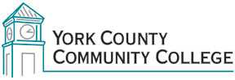

College Council
Tuesday: 4 October 2016
12:30 – 2:00 in the Middle Cafeteria

AGENDA
1. Call to Order

2. Approval of Agenda

3. Approval of Minutes

4. Updates
4.1 President’s Update (I)
4.2 Strategic Planning Committee (C)
4.3 Policy Committee (C)
4.4 Standing Committee reports (C)

5. Old Business

6. New Business

7. Announcements

8. Public Comment

9. Adjournment

Note: In keeping the College Council’s Agenda Item Request Form, agenda items are coded as follows: A= Action Item; C= Committee Report; D= Discussion; I= Information

