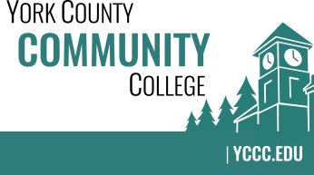

Strategic Planning Committee
Tuesday: April 25, 2017
2:30 – 4:00 in the Clocktower Conference Room

AGENDA

1. Call to order and roll call

2. Approval of meeting notes from Meeting #5 (3/2/2017)

3. Review and approval of agenda

4. Updates
4.1 ATD / President’s benchmark draft data
4.2 Final College Council meeting – SPC report
4.3 NEASC Reaccreditation Team – Standard 1 (Mission & Purpose) and Standard 2
(Planning & Evaluation)

5. Old business

6. New business
6.1 Share and review the actions/initiatives draft (D, A)
6.2 Tasks for 2017-2018 Committee, including the vision statement

7. Announcements

8. Public Comment

9. Adjournment

Note: In keeping the College Council’s Agenda practices, agenda items are coded as follows: A= Action Item; C= Committee Report; D= Discussion; I= Information

