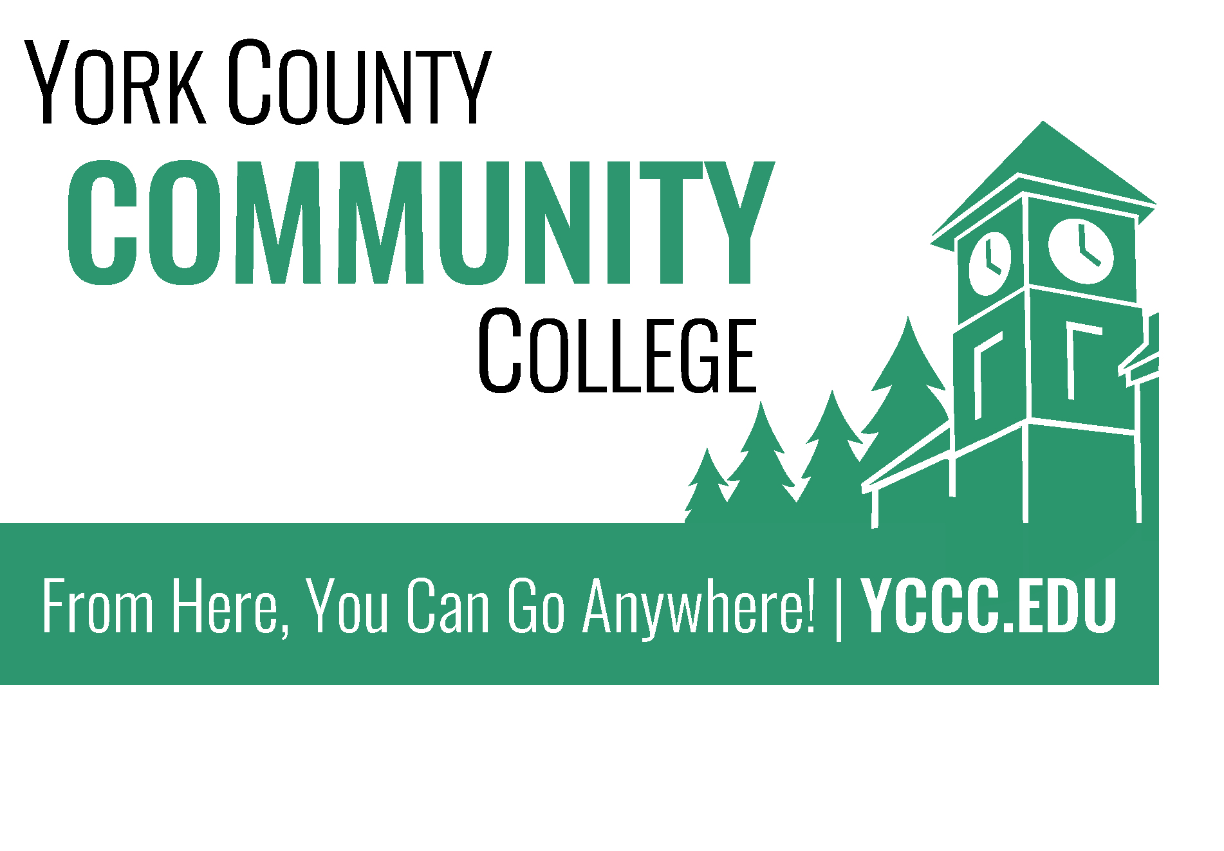
Strategic Planning Committee Update
November 1, 2016
Nicholas Gill, M.Ed. (Chair)

The staff have elected John Hall as there 2016-2017 staff selected representative on the Strategic Planning Committee.

The NEASC team that visited the college between October 17th-18th had the opportunity to meet with the majority of the Strategic Planning Committee. They were most impressed with the progress the college has made in creating a plan through community representation. In particular President Lombella was impressed with the committee’s energy and dedication to the importance of the planning process.

No peer review is complete without a couple areas of opportunity to further strengthen efforts. With that in mind, here are a couple suggestions NEASC strongly encouraged us to pursue.

- Try to get the student seat on the committee filled. The committee has forwarded information our bylaws and future meeting dates to several interested parties through Deidre Thompson in the Student Involvement Office.

- Community participation. Our committee was founded on the principals of representative governance. In the same way that every American cannot vote on the Senate floor, we know that in order for a group to be productive it must be inclusive as well as nimble. However, community input is important and must be incorporated to strengthen the transferability of our emerging plan. The committee will be discussing possible formats for soliciting community input at the November 11th meeting.

- Community awareness of documentation. According to the feedback the NEASC team gathered, the community knows about what the committee is doing and how they are doing it, thanks to the feedback given by community members to their represented constituents. However, there is still some confusion about the YCCC Portal, where it is, and how to access it. The committee chair will present a brief overview of the portal at the 11/1/2016 College Council meeting.

