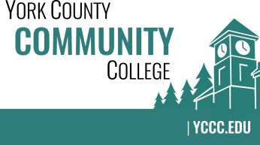

Strategic Planning Committee
Wednesday: November 29, 2017
2:30 – 3:30 in the Clocktower Conference Room

AGENDA

1. Call to order and roll call

2. Approval of meeting notes from previous meeting (10/25/2017)

3. Review and approval of agenda

4. Updates
4.1 Branding the New Strategic Plan

5. Old business

6. New business
6.1 Updating the plan; where and when (D, A)
6.2 NEASC Standard 1: Review and plan for input.

7. Announcements

8. Public Comment

9. Adjournment

Note: In keeping the College Council’s Agenda practices, agenda items are coded as follows: A= Action Item; C= Committee Report; D= Discussion; I= Information

