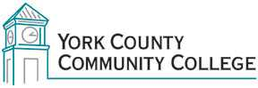

Strategic Planning Committee
Tuesday: February 25th, 2016
10:00 – 11:30 in the Clocktower Conference Room

AGENDA

1. Call to order and roll call

2. Approval of meeting notes from February 9, 2016

3. Review and approval of agenda

4. Updates

5. Old business

6. New business
6.1 Discuss ideas/goals for pending MCCS visit (D)
6.2 Review core concepts from February 9th meeting (D)
6.3 Review Goal alignment for YCCC Plan with the current MCCS Plan (D)

7. Announcements

8. Public Comment

9. Adjournment

Note: In keeping the College Council’s Agenda practices, agenda items are coded as follows: A= Action Item; C= Committee Report; D= Discussion; I= Information

