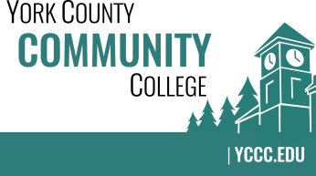

Strategic Planning Committee
Friday: January 25, 2019
2:30 – 3:30 in the Clocktower Conference Room

AGENDA

1. Call to order and roll call

2. Review and approval of agenda

3. Updates
3.1 MCCS strategic plan palm cards
3.2 MCCS “Measures and Indicators” dashboard updates

4. Old business
4.1 None

5. New business
5.1 Discuss the implications of multiple committee vacancies (D)
5.2 Decide on whether or not to proceed with YCCC version of planning palm cards (D, A)
5.3 Discuss ideas for event to promote Core Values (D)

6. Announcements

7. Public Comment

8. Adjournment

Note: In keeping the College Council’s Agenda practices, agenda items are coded as follows:
A= Action Item; C= Committee Report; D= Discussion; I= Information

