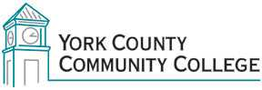

Strategic Planning Committee
Tuesday: February 9th, 2016
2:30 – 4:00 in the Clocktower Conference Room

AGENDA

1. Call to order and roll call

2. Approval of meeting notes from January 26, 2016

3. Review and approval of agenda

4. Updates

5. Old business

6. New business
6.1 Review Data packet including MCCS Student Success measures and AMR results (D)
6.2 Examine Data: Master Planning Survey results (D)
6.3 Review Goal alignment for YCCC Plan with the current MCCS Plan

7. Announcements

8. Public Comment

9. Adjournment

Note: In keeping the College Council’s Agenda practices, agenda items are coded as follows: A= Action Item; C= Committee Report; D= Discussion; I= Information

