How to Use MaineStreet:

What is it?
MaineStreet is the University of Maine system portal that handles many different functions. The are two important tools for considering your transfer options:
- Transfer Course Equivalencies
See what your YCCC courses will transfer to at any University of Maine campus. Directions to use below: (NOTE: final decision always resides with receiving institution and often the department faculty chair).
- Class Search
Look up a course at a University of Maine system campus to see when it's offered or what prerequisites it requires.
**Each transfer college admissions office will evaluate your transcript for final determinations.**

How to do a Transfer Equivalency Search
PLEASE NOTE: All YCCC courses, especially those that are new or have changed in the last year may not be posted to MaineStreet. In addition, some of the system campuses only update their MaineStreet when individual student’s from YCCC apply. It is ALWAYS best to review the information here first and then follow-up with the transfer admissions advisor at that college.

Step 1:
Enter MaineStreet via https://peportal.maine.edu/

Step 2 :
Click on "Transfer Course Equivalencies" on the left side of the screen
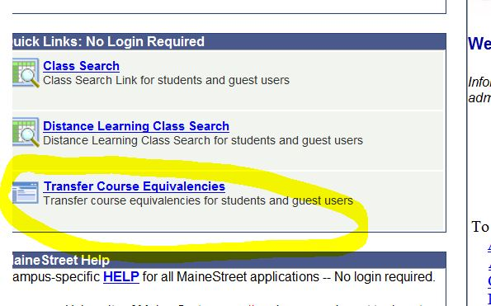
Step 3:
Click on "Transfer courses or test credit to the Univ. of Maine System" button
(the other button is if you need a specific class at a UMS campus you can find out all the colleges you can take the equivalent course)
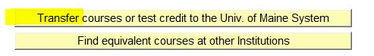
Step 4:
Select the UMS campus you want to see course transfer equivalencies for.
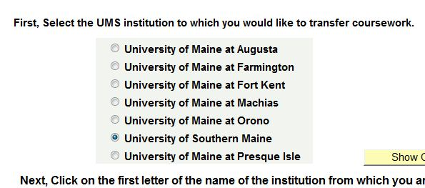

Step 5:
Click on the "Y" to get a list of colleges that begin with Y and then click on "York County Community College."
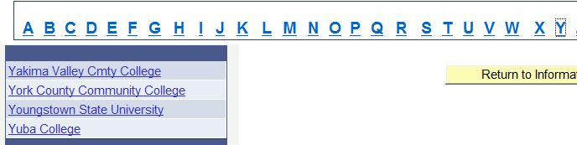

Step 6:
You can either choose a particular subject or "Show All Subjects" and you will get a grid of results.
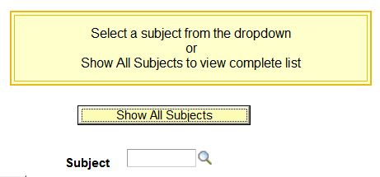

Step 7:
The grid will show you the Source Course and Title (YCCC) then the Target Course and Title (the UMS campus you selected). Depending on your screen size, you may need to scroll to the far right to see the "Gen Ed or Core Requirement" column which is also a useful tool. There may also be date restrictions on the validity of some courses displayed.

It is also important to note that you may see multiple entries for a similar course. Courses change names or number and this grid tries to capture this historical data.
