Fall 2019 Advisor List

This information is subject to change. Please be sure to login to the MyYCCC portal at the end of the Add/Drop period to access your advisor information.

Offices will be located at one of three locations: YCCC Main Building, Pratt & Whitney Building (both located at 112 College Dr. Wells, ME 04090), or Sanford PMT Building (located at 60 Community Dr. Sanford, ME 04073).

Advisor Name: Office #: Email: Phone:
(if applicable) (if applicable)

Cathleen Ferrick B219 - Main cferrick@yccc.edu 207.216.4379
Charlie Galemmo B105E - Main cgalemmo@yccc.edu 207.216.4372
Claudette Dupee A102G - Main cdupee@yccc.edu 207.216.4479
David Susman B105F - Main dsusman@yccc.edu 207.216.4358
Denise Young A212 - Main dyoung@yccc.edu 207.216.4404
Dianne Fallon B217 - Main dfallon@yccc.edu 207.216.4357
George Fowler B102B - Main gfowler@yccc.edu 207.459.4306
Jean Mitchell N/A jmitchell@yccc.edu N/A
Jennifer Healy B105K- Main jhealy@yccc.edu 207.216.4355
Jennifer Mallett B219 - Main jmallett@yccc.edu 207.216.4380
Krista Marvel B103 - Main kmarvel@yccc.edu 207.216.4381
Lauren Mayhew B212 – Main lmayhew@yccc.edu 207.216.4368
Lee Kassler Sanford PMT Bldg. lkassler@yccc.edu 207.216.4369
Lisa Murphy B216 - Main lmurphy@yccc.edu 207.216.4362
Margaret (Peg) Wheeler B105A - Main mwheeler@yccc.edu 207.216.4375
Maria Niswonger B215 - Main mniswonger@yccc.edu 207.216.4363
Matt Kaszubinski B105C1 - Main mkaszubinski@yccc.edu 207.216.4373
Mike Jones Sanford PMT Bldg. michaelejones@yccc.edu 207.216.4376
Mike Lee B105M - Main mlee@yccc.edu 207.216.4367
Paul Archer N/A parcher@yccc.edu 207.216.4399
Sam Kelley B214 - Main skelley@yccc.edu 207.216.4365
Stephen Paulone B105J - Main spaulone@yccc.edu 207.216.4353
Susan Slosky B102B - Main sslosky@yccc.edu 207.646.9282 ext. 4354
Tom McGinn B105B - Main tmcginn@yccc.edu 207.216.4366
Tracey Cornell B105D - Main tcornell@yccc.edu 207.216.4361
Wesley Mills B105L - Main wmills@yccc.edu 207.216.4359

How to Locate Your Faculty Advisor:

- Visit www.yccc.edu and click on MyYCCC (this is your student portal) at the top right corner.

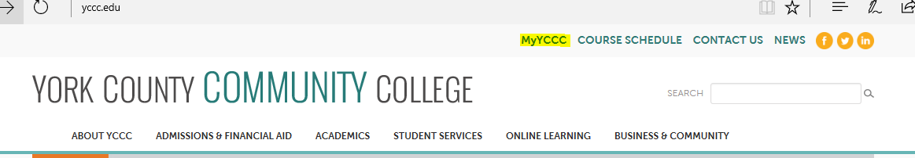

- Enter your login credentials:

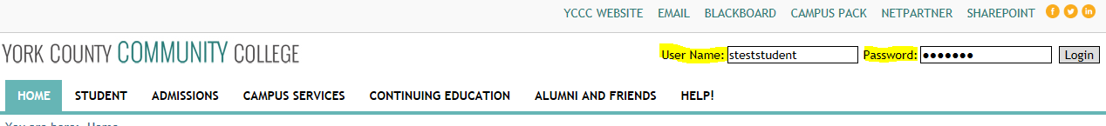

- Once you have logged in, click on “Student” tab and then “Advising”.
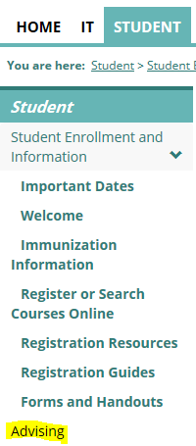

- Next, scroll to the bottom to view “My Academic Information”. Here you will see your advisor(s) listed.
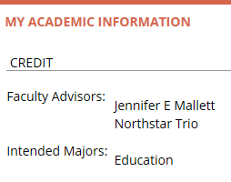
Revised 09/2019

