What is Consent?
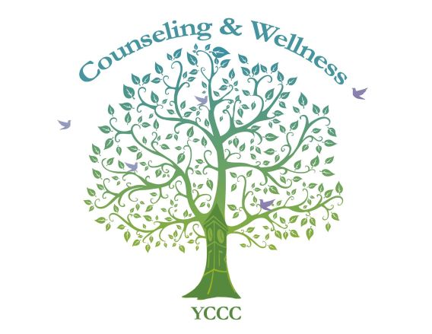
Consent is
- ongoing (keep checking in, “Is this okay?”)
- sober
- about all types of sexual encounter, not just intercourse
- having the right to say “no” no matter how long you have known the other person or how you are legally or not legally attached
Consent is NOT
- assumed (always ask, and keep asking)
- not silent (silence does not mean “yes”)
- not presumed due to previous sexual encounters with the same person
- flirting (if a person flirts with you, it does not mean they want sex with you)
- expecting that you will have sex whenever you want to, because you are a couple
- “owed” to you, because you did someone a favor (if you pay for dinner, give a ride to someone, help them out…)

It’s never too late to communicate to your partner about consent. If you feel in danger, or wish to speak to a counselor, please call Penny Remick at 216-4415, email ypremick@yccc.edu
Or contact Sexual Assault Response Services of Southern Maine at 1-800-871-7741, 24 hours a day, 7 days a week to phone or text them, or email or chat with them at sarsonline.org.

