What is Sexual Assault?
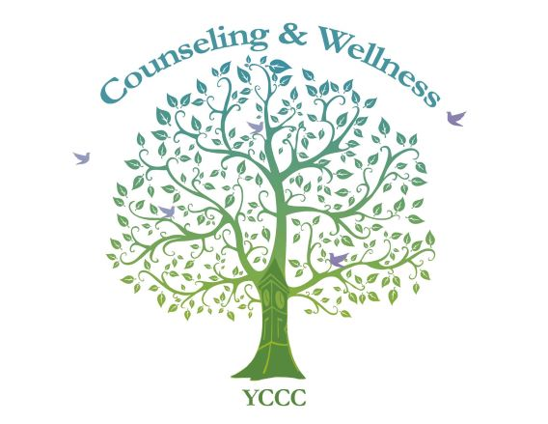
- Any type of sexual contact without consent is sexual assault.
- Without consent, a crime is committed.
- Rape means there was a lack of consent.
- Consent may be implied, not simply or always communicated. For example, if someone is asleep or intoxicated, or both, consent is not possible.

Maine Law:

https://statelaws.findlaw.com/maine-law/maine-rape-and-sexual-assault-laws.html

http://legislature.maine.gov/statutes/17-A/title17-Ach11sec0.html
It’s never too late to communicate to your partner about consent. If you feel in danger, or wish to speak to a counselor, please call Penny Remick at 216-4415, email ypremick@yccc.edu
Or contact Sexual Assault Response Services of Southern Maine at 1-800-871-7741, 24 hours a day, 7 days a week to phone or text them, or email or chat with them at sarsonline.org.

